**Research Guide**

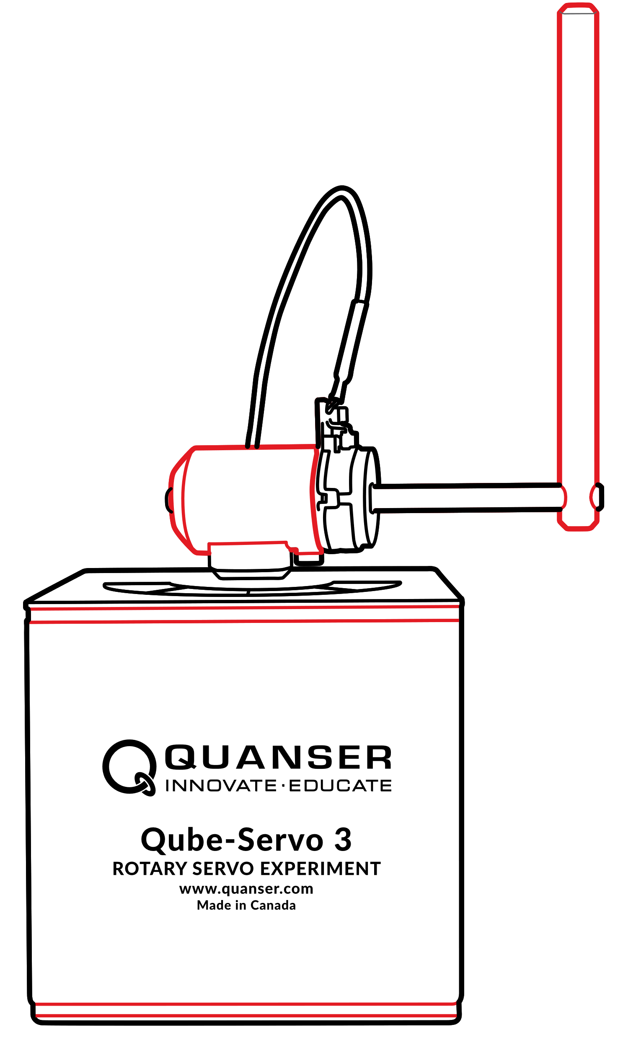

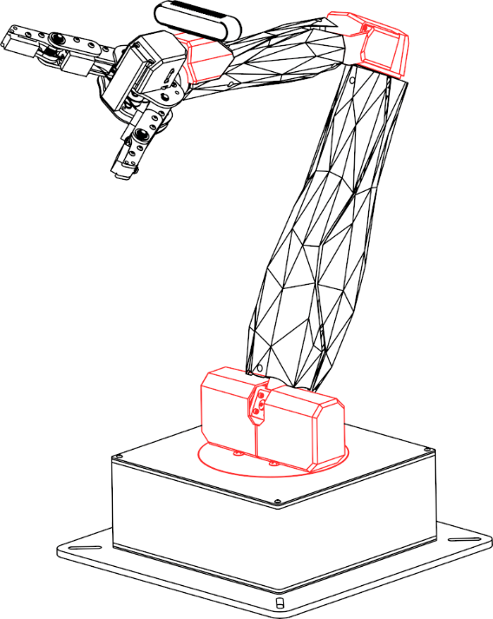

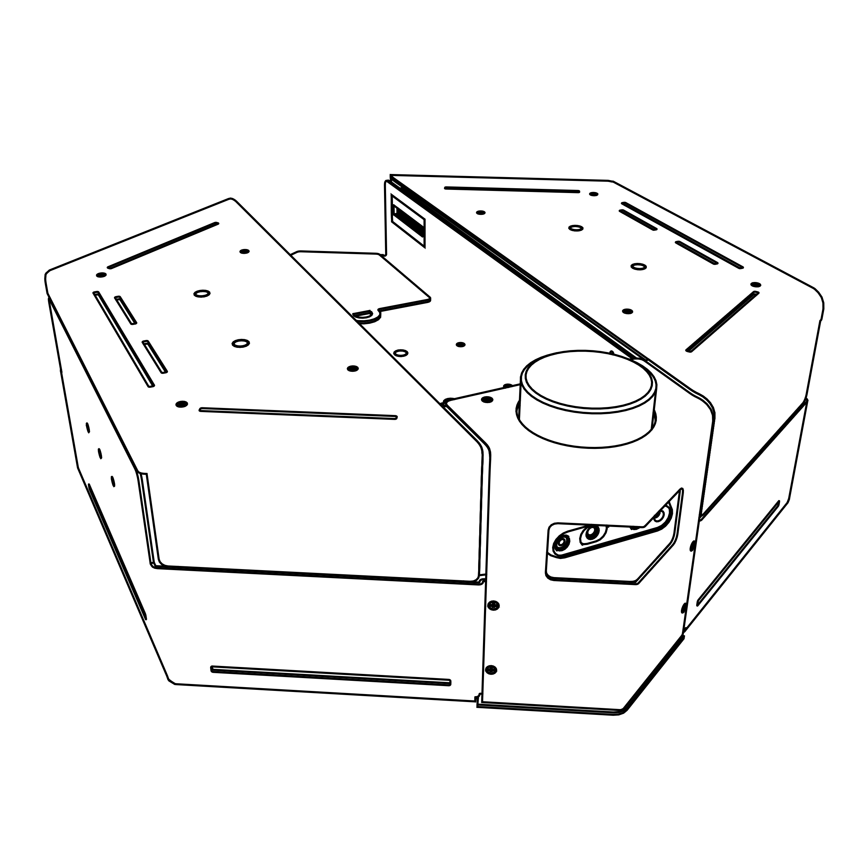

Content Guide

V1.0 – 12th February 2025

© 2025 Quanser Consulting Inc., All rights reserved.

For more information on the solutions Quanser offers,   
please visit the web site at: <http://www.quanser.com>

|  |  |
| --- | --- |
| Quanser Consulting Inc.  119 Spy Court  Markham, Ontario  L3R 5H6, Canada | info@quanser.com  Phone : 19059403575  Fax : 19059403576  printed in Markham, Ontario. |

This document and the software described in it are provided subject to a license agreement. Neither the software nor this document may be used or copied except as specified under the terms of that license agreement. Quanser Consulting Inc. (“Quanser”) grants the following rights: a) The right to reproduce the work, to incorporate the work into one or more collections, and to reproduce the work as incorporated in the collections, b) to create and reproduce adaptations provided reasonable steps are taken to clearly identify the changes that were made to the original work, c) to distribute and publicly perform the work including as incorporated in collections, and d) to distribute and publicly perform adaptations. The above rights may be exercised in all media and formats whether now known or hereafter devised. These rights are granted subject to and limited by the following restrictions: a) You may not exercise any of the rights granted to You in above in any manner that is primarily intended for or directed toward commercial advantage or private monetary compensation, and b) You must keep intact all copyright notices for the Work and provide the name Quanser for attribution. These restrictions may not be waved without express prior written permission of Quanser.

Background

Welcome to the Quanser research resources! In this document we will focus on the wide variety of research examples provided by Quanser. A visual representation of the content available:

**aero2**

**applied ai**

**Multi agent**

**pal utilities**

**Autonomous Vehicles**

**Research**

**qarm**

**qarm mini**

**qbot platform**

**qbot platform alpha**

**qube servo**

**sdcs**

Note that the **Autonomous Vehicles** folder has examples for QDrone, QDrone 2, QBot 2, QBot 2e, QBot 3. The **SDCS** folder has examples for QCar, QCar 2 and the Traffic Light.

Getting started

1. If your institution has a Quanser lab please review **1-setup** before getting started.
2. For quick device level tests and getting started please review **2-quick start guides**  to become familiar with the products you have available.
3. Before using Quanser’s products, be sure to read the user manuals located in **3-user manuals**.
4. For examples, research applications and advanced use of Quanser products, please review the research_content_guide.docx under **5-research**.
5. For the teaching or student content provided by Quanser, please review teaching_content_guide.docx under **6-teaching** to view the available resources. These resources might suggest reviewing content uncer the **4-concept reviews** folder.

Before getting started with research examples please keep in mind research examples are composed in a variety of development environments. Use the following table to identify which development emvironemnts meet your research needs

|  |  |  |  |
| --- | --- | --- | --- |
|  | MATLAB/Simulink | Python | ROS |
| Aero2 | 🗸 | 🗸 | 🗴 |
| Applied AI | 🗴 | 🗸 | 🗴 |
| Autonomous  Vehicles | 🗸 | 🗸 | 🗴 |
| Multi Agent | 🗸 | 🗸 | 🗴 |
| pal utilities | 🗴 | 🗸 | 🗴 |
| QArm | 🗸 | 🗸 | 🗸 |
| QArm Mini | 🗴 | 🗸 | 🗴 |
| QBot Platform | 🗸 | 🗸 | 🗸 |
| QBot Platform Alpha | 🗸 | 🗸 | 🗴 |
| Qube Servo | 🗸 | 🗸 | 🗴 |
| SDCS | 🗸 | 🗸 | 🗸 |

Considerations when getting started with research examples:

1. If the system at your institution has curriculum content available have you had an opportunity to go through it and understood the operating constraints of the system?
2. Does your knowledge of these development environments meet a minimum threshold? The following are considerations and questions to ask yourself before getting stated.
   1. For MATLAB/Simulink examples, do you know how to:
      1. Get around a Simulink model, drop in blocks, set the step size for a model, specify the target device that code will compile for, where the code is actually running? See the [Simulink Onramp](https://matlabacademy.mathworks.com/details/simulink-onramp/simulink) for more help with getting started with Simulink.
      2. Checked out the list of available QUARC blocks to help you get started? If you haven’t please take a look at the following link to get an understanding of the core functionalities that Quanser has put together <https://docs.quanser.com/quarc/documentation/quarc_demos.html>
   2. For Python users do you know how to:
      1. Import and call libraries inside a python script?
      2. Understand the basics of timing and how to enforce a specific time step during a python application?
      3. Understand whether or not the example is designed for the host computer or the actual Quanser device?

Ex: for devices like the QCar 2 you can run python examples locally on the QCar to read data and perform a task. This requires you to copy and run files on the system. Do you have an understanding of how to complete these steps?

* 1. For ROS users do you know how to:
     1. Compile your ROS distro?
     2. Created a python/C++ ROS node in the past?
     3. Understand the differences between ROS 1 and ROS 2 distributions?
     4. Understand how worskpaces, packages, nodes work and their folder structure?